**Thanks to the families that sent in Legos for our basket! The carnival was a huge success and the kids had a great time! Thank you to families that worked a shift at our booth. We couldn’t have done it without you! Huge thank you to Mrs. Powell for making our basket and keeping us organized!**



**Savvas Reading-**

**Unit 4 Week 2**

***Focus Question:*** How do we learn about the past?

***Text: Uncovering the Past***

***Letter Recognition & Sounds:***

Short Ee/ Long Ee

***Sight Words:***

Pretty, of, now, with

***Vocabulary:***

past, shovels, brushes, scientists

***Genre:*** Narrative Nonfiction

***Language and Conventions:***

Kinds of Sentences

**Math- *Chapter 7: Teen Numbers***

The chapter 7 test will be on Friday, February 24th.

**Social Studies-**

Presidents Day

George Washington and Abraham Lincoln



On **Tuesday, February 14th**, our class will celebrate by exchanging Valentines with our friends and sharing a friendship treat together.

Please have your child bring in valentines to exchange with their classmates. Have them sign the cards on the inside. I attached a class list so that your child can address the envelope.

(Example- to: Johnny from: Sarah)



**Terrific Kid**

Mahum

**Tuesday, 2/14**

**Valentine’s Day Fun**

**Monday, 2/20**

**Presidents Day**

**(no school)**

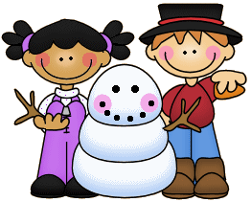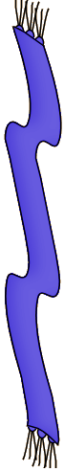

**Sonja Darden’s Kindergarten Class**

**Buck Lake Elementary** 488-6133 [dardens@leonschools.net](mailto:dardens@leonschools.net)

**February 13, 2023**

